Name:_________________________ Quiz 6

1. There are three types of muscles found in the body:

___________: involuntary muscle not associated with locomotion

___________: muscle responsible for contractions of the atria and ventricles of the heart

___________: striated, voluntary muscle associated with body movements

1. Name the three parts of a striated muscle.
2. Label the following muscle types.

**E**

**D**

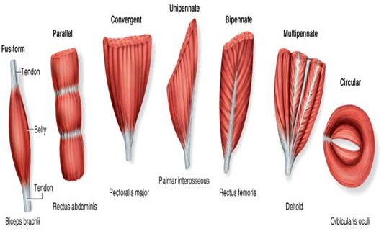

A ___________________

**F**

**C**

**B**

**A**

B ___________________

C ___________________

D ___________________

E ___________________

F ___________________

1. The basic design of the musculature of sharks consists of serially arranged ______________ separated by ________________.
2. Ventrally on the shark, a thin, longitudinal line of connective tissue, the _________________ meets the mid ventral vertical septum.
3. The lateral musculature of the shark is divided into dorsal ____________ muscles and ventral _____________ muscles, which are divided by a sheet of connected tissue called the horizontal septum.

WORD BANK

